Subject: Year 11 Mock 1 2024
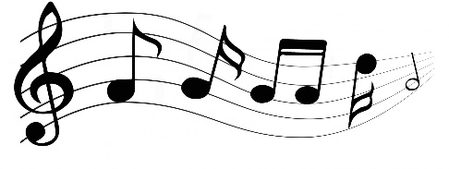
MUSIC

Being Organised

Please give a brief description of the following:

- Revision resources pupils have received from the department
- Rhinegold revision guides and listening tests

- What resources pupils should bring to each lesson
- Exercise book and composition work

- What resources pupils should bring to each revision session
- Exercise book

Independent Revision

Please give a brief description of independent revision tasks pupils could complete in addition to their homework. This should be different tasks from any homework or classwork which has been set throughout the 6 week plan. Please include what revision materials pupils should use to complete these tasks.
2 - 3 hours of instrument practice each week, including warm up/technique/studies/scales/arpeggios etc.
Scrutinising compositions and incorporating various musical features

Exam Board Guidance

Insert a link to the exam specification.
https://www.ocr.org.uk/qualifications/gcse/music-j536-from-2016/

Other Online Material

Insert links to all online revision materials pupils could use.
https://www.youtube.com/watch?v=wXtYLSKXjgo&list=PLNeHS3oeH242gKpGrZAA-xvafcIOjjpw6

https://www.youtube.com/watch?v=1aH6TGNmRmE&list=PL95qU4tGYrH1rKDD-vM3uuXhq2nDskrtp

https://www.youtube.com/watch?v=p6xJGxboCW8&list=PLyNdGKxoYqifliha9-a7FIEFQ8s7QGNvp

There are several excellent GCSE playlists, such as: https://open.spotify.com/playlist/3O1QMoJVkY22iGwyT7edn5

Include at least one link to each of the following:

- https://www.youtube.com/watch?v=T81tIbQmT_M&list=PLtycXRMafBjmCB7xZHsvD5C7fbxbRLd3L

- https://www.youtube.com/watch?v=B25mUU8nn60

