Biology: Organised and Ready for Year 11 Mock Exams

Being Organised

Every pupil has a revision guide published by CGP, page numbers will be on the revision guide sheet provided by the Science Department. They cover the exam papers. THIS IS THE BEST PLACE TO START REVISION.

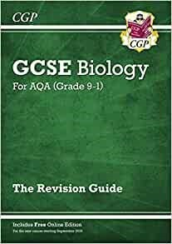
Triple Revision guide: (Paper will be 1 ¾ hours long)

Topics on Triple Paper 1 Mock:
B1 – Cell Biology [pages 11-26]
B2 – Organisation [pages 27 -45]
B3 – Infection & Response [pages 46-56]
B4 – Bioenergetics [pages 57-64]

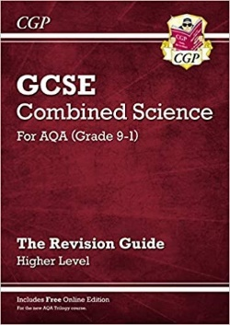
Combined Revision guides: (Paper will be 1 ¼ hours long)

Topics on HIGHER Paper 1 Mock​
B1 – Cell Biology [pages 11-23]​
B2 – Organisation [pages 24 -42]​
B3 – Infection & response [pages 43-49]​
B4 – Bioenergetics [pages 50-57]

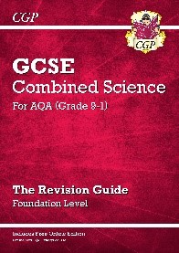
Topics on FOUNDATION Paper 1 Mock​
B1 – Cell Biology [pages 11-23]​
B2 – Organisation [pages 24 -41]​
B3 – Infection & Response [pages 42-49]​
B4 – Bioenergetics [pages 50-56]

There are further revision materials published by the Biology Department of St Leonard’s, for each paper.

Exam Board Guidance (AQA)

Exam Board specification: Triple and Combined
Past Papers: Triple and Combined

Other Online Material

Triple:
BBC Bitesize triple

Combined:
BBC Bitesize Combined Science

Chemistry: Organised and Ready for Year 11 Mock Exams

Being Organised

Every pupil has a revision guide published by CGP, page numbers will be on the revision guide sheet provided by the Science Department. They cover the exam papers. THIS IS THE BEST PLACE TO START REVISION.

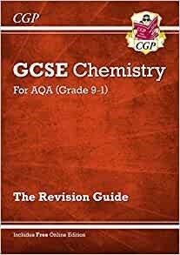
Triple Revision guide: (Paper will be 1 ¾ hours long)
C1 – Atomic Structure and Periodic Table [pages 12-27]​
C2 – Structure and Bonding [pages 28-40]​
C3 – Calculations [pages 41-50]​
C4 – Chemical Changes [pages 51-60]​
C5 – Energy Changes [pages 61-66]

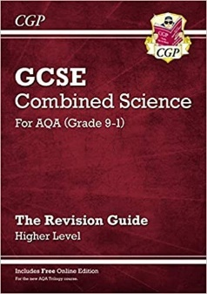
Combined Revision guide: (Paper will be 1 ¼ hours long)

Topics on HIGHER Paper 1 Mock​
C1 – Atomic Structure and Periodic Table [pages 96-111]​
C2 – Structure and Bonding [pages 112-122]​
C3 – Calculations [pages 123-128]​
C4 – Chemical Changes [pages 129-137]​
C5 – Energy Changes [pages 138-141]

Topics on FOUNDATION Paper 1 Mock​
C1 – Atomic Structure and Periodic Table [pages 96-112]​
C2 – Structure and Bonding [pages 113-122]​
C3 – Calculations [pages 123-127]​
C4 – Chemical Changes [pages 128-133]​
C5 – Energy Changes [pages 134-137]

There are further revision materials published by the Chemistry Department of St Leonard’s, for each paper.

Exam Board Guidance (AQA)

Exam Board specification: Triple and Combined
Past Papers: Triple and Combined

Other Online Material

Triple:
BBC Bitesize triple chemistry
Combined:
BBC Bitesize Combined Science

Physics: Organised and Ready for Year 11 Mock Exams

Being Organised

Every pupil has a revision guide published by CGP; page numbers will be on the revision guide sheet provided by the Science Department. They cover the exam papers. THIS IS THE BEST PLACE TO START REVISION.

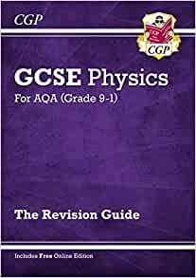
Triple Revision guide: (Paper will be 1 ¾ hours long)
P1 – Energy [pages 11-23]​
P2 – Electricity [pages 24-37]​
P3 – Particle model of matter [pages 38-42]​
P4 – Atomic structure [pages 43-50]​

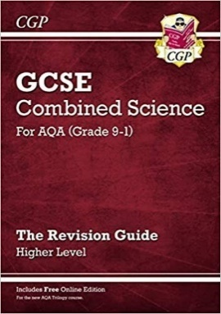
Combined Revision guide: (Paper will be 1 ¼ hours long)

Topics on HIGHER Paper 1 Mock​
P1 – Energy [pages 167-178]​
P2 – Electricity [pages 179-190​
P3 – Particle model of matter [pages 191-194]​
P4 – Atomic structure [pages 195-200]​

Topics on FOUNDATION Paper 1 Mock​
P1 – Energy [pages 167-179]​
P2 – Electricity [pages 180-192]​
P3 – Particle model of matter [pages 193-196]​
P4 – Atomic structure [pages 197-202]​

There are further revision materials published by the Physics Department of St Leonard’s, for each paper.

Exam Board Guidance (AQA)

Exam Board specification: Triple and Combined
Past Papers: Triple and Combined

Other Online Material

Triple:
BBC Bitesize triple physics
Combined:

BBC Bitesize Combined Science

